Name _________________________________________

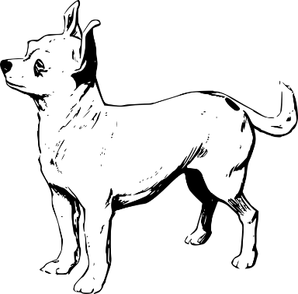
The Itsy Bitsy Doggie
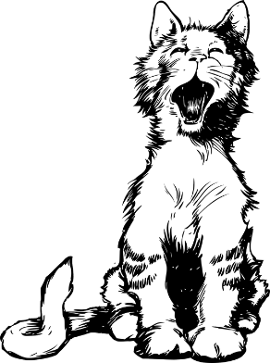
The itsy bitsy doggie smelled a yummy treat
He climbed up on the comfy bed
To see what he could eat
Down came the mad cat from the pillow head
Then out came the girl yelling, “Get off of my bed!”
And the itsy bitsy doggie tried to climb the bed again!
- How did the cat feel?
  - mad
  - sad
  - happy
  - silly
- How did the bed feel?
  - hard
  - soft
  - comfy
  - cold
- What did the doggie try to see?
  - the cat
  - the treat
  - the girl
  - the pillow

- How did the girl feel?
  - happy
  - angry
  - excited
  - embarrassed
- Which two words rhyme?
  - doggie and bed
  - bed and head
  - girl and again
  - climb and bed
- Which two words rhyme?
  - eat and treat
  - bed and again
  - treat and bed
  - eat and again

