In celebration of Earth Day April 22nd, read the poem and complete part A.
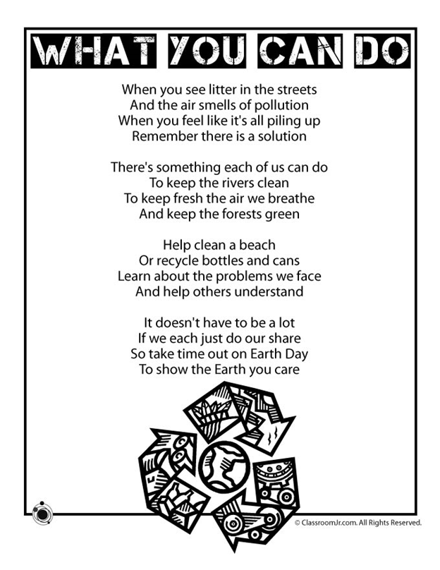
A.
Using complete sentences, write at least four things you and your family can do to take care of our planet.

1.

2.

3.

4.

