Read the Names poem. Answer the questions below.

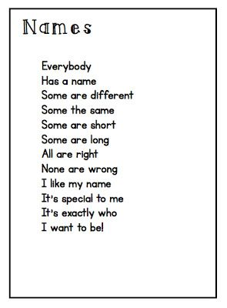

- Write the name of someone you know with a short name.

- Write the name of someone you know with a long name.

- Write down the rhyming word pairs.

joyfullearninginkc.blogspot.com

