Kindergarten and 1st Grades (Week 8)

**For past assignments please click on Useful Links and the ongoing Reading Log.
Kindergarten and 1st Grade (Week 8)
Name: _______________________________ Date: _________

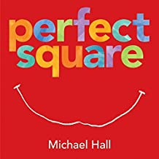

Please follow the link below to the story Perfect Square by Michael Hall. Next create something out of a square piece of paper. Then write 2-3 sentences telling what you made, what it does and why you made it.
https://www.youtube.com/watch?v=rRqL7GUaavc

