2nd Grade (Week 9)

**For past assignments please go to Useful Links and see the file the for the ongoing Reading Log.
Name______________________________________ Date________________
2nd Grade (Week 9)
Please click on the link below to listen to Miss Maple's Seeds by Emma Wheeler.
Then answer the question below.

https://www.youtube.com/watch?v=ShaO355bpDQ
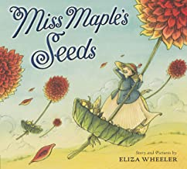
Imagine you are planting a garden. What would you grow in your garden and why?

